Home » Blogs » George Washington's blog

The Real Reason America Is Drifting Towards Fascism
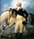
Submitted by George Washington on 10/21/2012 15:18 -0400
[The below speaks more to fascism among nations than within a nation. –FNC]

Step 1: Demonizing the Enemy
War is always sold by artificially demonizing the enemy.
Countries need to lie about their enemies in order to demonize them sufficiently so that the people will support the war.
Everyone knows that “truth is the first casualty of war“.
As Tom Brokaw said:
All wars are based on propaganda.
Posters prepared in foreign countries demonizing Americans are an obvious form of propaganda. For example, here are samples from
Nazi Germany:
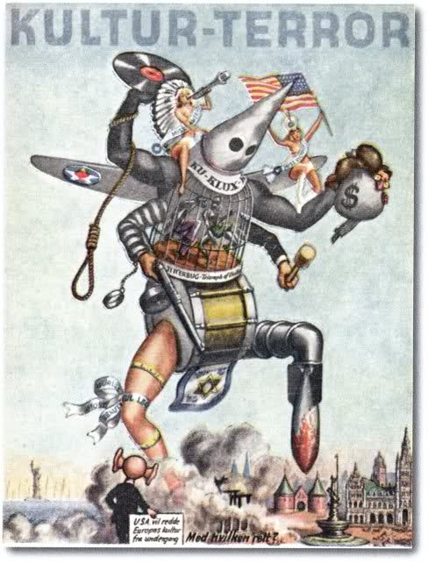
The Soviet Union:
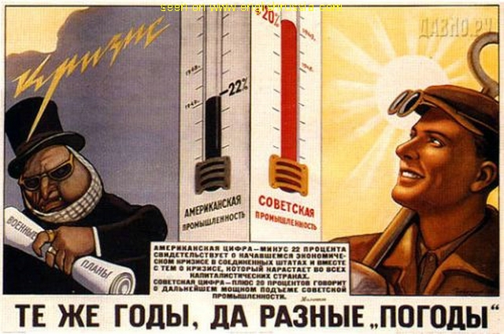
(the American is supposed to be the guy on the left)
North Korea:
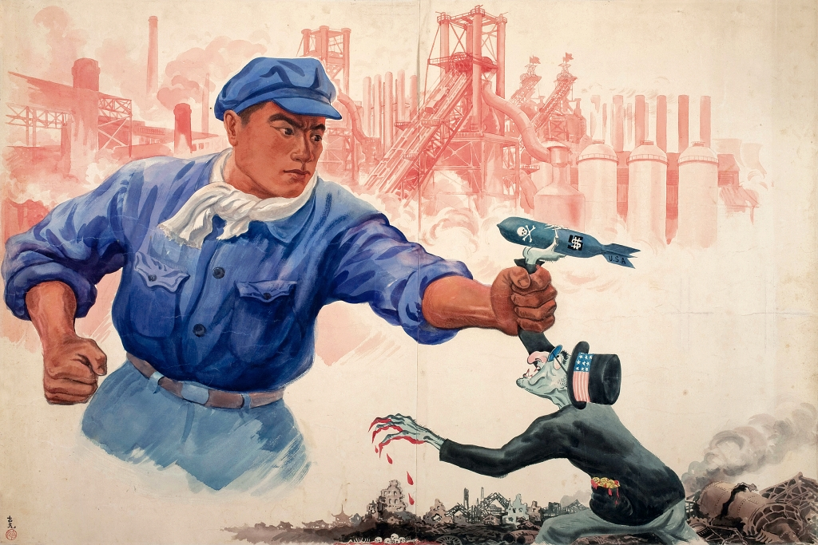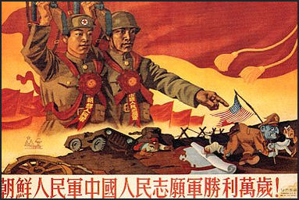
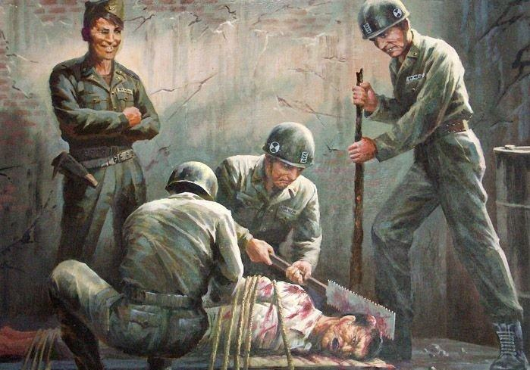These are disturbing images, because we as Americans know that they falsely depict who we are.
But Americans have demonized our enemies as well. For example, in World War II, anti-Japanese posters such as the following were used to whip up hatred of the enemy:
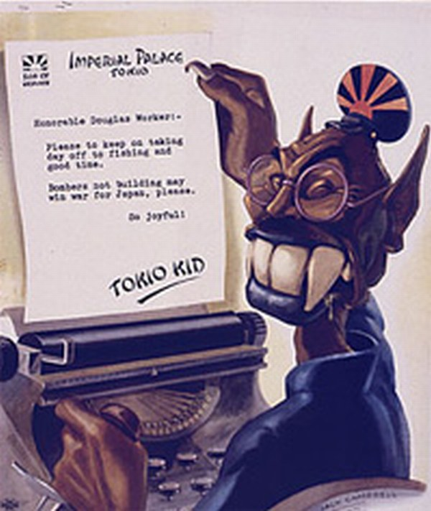
Anti-German posters such as this were also widely used:
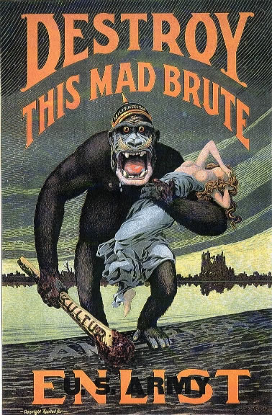
And, at times, Americans have even demonized other Americans, such as during the Civil War:
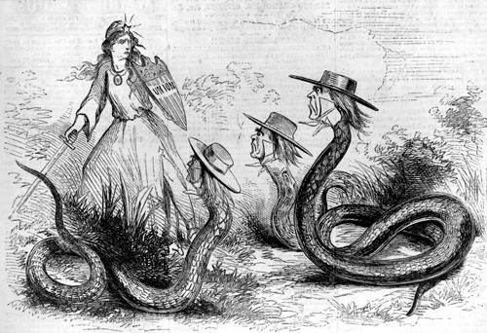

Modern America’s Unique Form of Authoritarianism
The unique modern strain of American fascism can be traced through Leo Strauss and the University of Chicago.
Leo Strauss is the father of the Neo-Conservative movement, including many leaders of recent American administrations. Indeed, many of the main neocon players – including Paul Wolfowitz, Richard Perle, Stephen Cambone, Elliot Abrams, and Adam Shulsky – were students of Strauss at the University of Chicago, where he taught for many years.
The people pushing for war against Iran are the same neocons who pushed for war against Iraq. See this and this. (They planned both wars at least 20 years ago.) For example, Shulsky was the director of the Office of Special Plans – the Pentagon unit responsible for selling false intelligence regarding Iraq’s weapons of mass destruction. He is now a member of the equivalent organization targeting Iran: the Iranian Directorate.
What did Strauss teach?
Strauss, born in Germany, was an admirer of Nazi philosophers such as Carl Schmitt and of Machiavelli (more on Schmitt later).
Strauss believed that a stable political order required an external threat and that if an external threat did not exist, one should be manufactured. Specifically, Strauss thought that:
A political order can be stable only if it is united by an external threat . . . . Following Machiavelli, he maintained that if no external threat exists then one has to be manufactured.
(the quote is by one of Strauss’ main biographers).
Indeed, Stauss used the analogy of Gulliver’s Travels to show what a Neocon-run society would look like:
“When Lilliput [the town] was on fire, Gulliver urinated over the city, including the palace. In so doing, he saved all of Lilliput from catastrophe, but the Lilliputians were outraged and appalled by such a show of disrespect.” (this quote also fromthe same biographer)
Moreover, Strauss said:
Only a great fool would call the new political science diabolic . . . Nevertheless one may say of it that it fiddles while Rome burns. It is excused by two facts: it does not know that it fiddles, and it does not know that Rome burns.
So Strauss seems to have advocated governments letting terrorizing catastrophes happen on one’s own soil to one’s own people — of “pissing” on one’s own people, to use his Gulliver’s travel analogy. And he advocated that government’s should pretend that they did not know about such acts of mayhem: to intentionally “not know” that Rome is burning. He advocated messing with one’s own people in order to save them from some artificial “catastrophe”. In other words, he proposed using deceit in order to demonize an adversary and artificially turn him into a dangerous enemy.

Genesis of the Meme: Carl Schmitt
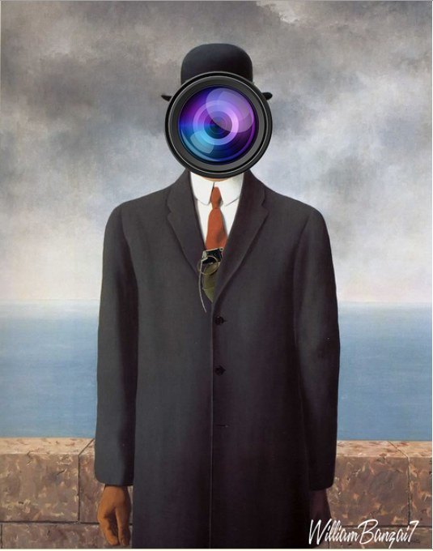Painting byWilliam Banzai 7
But to really understand Strauss – and thus the Neocons – one must understand his main influence: Carl Schmitt. Schmitt was the leading Nazi legal scholar and philosopher who created the justification for “total war” to destroy those labeled an “enemy” of the Nazi state.
Strauss was a life-long follower of Schmitt, and Schmitt helped Strauss get a scholarship which let him escape from Germany and come to America.
Not only was Strauss heavily influenced by Schmitt, but Strauss and Schmitt were so close that – when Strauss criticized Schmitt for being too soft and not going far enough – Schmitt agreed:
Schmitt himself recommended Strauss’s commentary [on Schmitt's writing] to his friends as one that he believed saw right through him like an X-ray.
Schmitt’s philosophy argued that the sovereign was all-powerful in being able to to declare a state of emergency. As Neil Levi explains:
The sovereign is the name of that person (legal or actual) who decides not only that the situation is a state of exception but also what needs to be done to eliminate the state of exception and thus preserve the state and restore order. Note the circularity of the definitions: the sovereign is the one who decides that there is a state of exception; a state of exception is that which the sovereign deems to be so.
Moreover:
The sovereign eliminates the state of exception to restore order, but the content of this order is historically contingent, because it is dependent on the sovereign’s will. All that matters to Schmitt is, as Slavoj Žižek puts it, “the decision for the formal principle of order as such.” Similarly, Schmitt says nothing, can say nothing, about what it is that makes a [principle] worth defending with one’s life, what substance and concrete content could or should compel one to make such a commitment to preserve this form.
Indeed, Schmitt says that “politics” is not the process of debate, making trade-offs, building consensus or letting the best ideas win. Instead, the sovereign – through an act of will – makes a decision, and then the political system should carry it out, and the military effectuate it.
George W. Bush’s statement that he was the “decider” fits in nicely with Schmitt’s theories.
Moreover, Schmitt argued that war against one’s enemy is total – lacking any legal constraints – but the sovereign can use ever-shifting definitions of who the enemy is:
War is the existential negation of the enemy.

***

As with the state of exception, there are not rational criteria for distinguishing friend from enemy. All conflict is situational conflict.
Similarly, Al Qaeda has been our “mortal enemy” since 9/11 … but now they are our close ally.
Indeed, Schmitt said that those who are like our “brothers”, who are as much the same as different from us, must be demonized so that we don’t feel any compassion for them. They are either “with us or against us”, regardless of whether or not they are good people, or how close to us they may be.
The Georgetown University Law Center notes:
Schmitt denounces all “neutralizations and depoliticizations,” which for him are the hallmarks of liberalism. There are no neutralizations: if you are not with us you are against us and we will destroy you: “If a part of the population declares that it no longer recognizes enemies, then, depending on the circumstance, it joins their side and aids them.”
Indeed, Schmitt believed that demonization and war must be maintained for their own sake, or else a horrible world where peace and culture reined would be created:
Schmitt writes that if war became impossible, then “the distinction of friend and enemy would also cease” and what remained would be “neither politics nor state, but culture, civilization,economics, morality, law, art, entertainment, and so on”….
A continuous “state of emergency” is required for the type of leadership advocated by Schmitt and Strauss. In 2002, Slavoj Žižek pointed out how this continuous state of emergency works:
A notable precursor in this field of para-legal ‘biopolitics’, in which administrative measures are gradually replacing the rule of law, was Alfredo Stroessner’s regime in Paraguay in the 1960s and 1970s, which took the logic of the state of exception to an absurd, still unsurpassed extreme. Under Stroessner, Paraguay was – with regard to its Constitutional order – a ‘normal’ parliamentary democracy with all freedoms guaranteed; however, since, as Stroessner claimed, we were all living in a state of emergency because of the worldwide struggle between freedom and Communism, the full implementation of the Constitution was forever postponed and a permanent state of emergency obtained. This state of emergency was suspended every four years for one day only, election day, to legitimise the rule of Stroessner’s Colorado Party with a 90 per cent majority worthy of his Communist opponents. The paradox is that the state of emergency was the normal state, while ‘normal’ democratic freedom was the briefly enacted exception. This weird regime anticipated some clearly perceptible trends in our liberal-democratic societies in the aftermath of 11 September. Is today’s rhetoric not that of a global emergency in the fight against terrorism, legitimising more and more suspensions of legal and other rights? The ominous aspect of John Ashcroft’s recent claim that ‘terrorists use America’s freedom as a weapon against us’ carries the obvious implication that we should limit our freedom in order to defend ourselves. Such statements from top American officials, especially Rumsfeld and Ashcroft, together with the explosive display of ‘American patriotism’ after 11 September, create the climate for what amounts to a state of emergency, with the occasion it supplies for a potential suspension of rule of law, and the state’s assertion of its sovereignty without ‘excessive’ legal constraints. America is, after all, as President Bush said immediately after 11 September, in a state of war. The problem is that America is, precisely, not in a state of war, at least not in the conventional sense of the term (for the large majority, daily life goes on, and war remains the exclusive business of state agencies). With the distinction between a state of war and a state of peace thus effectively blurred, we are entering a time in which a state of peace can at the same time be a state of emergency.
Columbia Law School professor Scott Horton notes that Schmitt’s philosophy formed the basis of the famous torture memos:
Where exactly did [Department of Justice torture memo author John] Yoo come up with the analysis that led to the purported conclusions that the Executive was not restrained by the Geneva Conventions and similar international instruments in its conduct of the war in Iraq? Yoo’s public arguments and statements suggest the strong influence of one thinker: Carl Schmitt.

***

Perhaps the most significant German international law scholar of the era between the wars, Schmitt was obsessed with what he viewed as the inherent weakness of liberal democracy. He considered liberalism, particularly as manifested in the Weimar Constitution, to be inadequate to the task of protecting state and society menaced by the great evil of Communism. This led him to ridicule international humanitarian law in a tone and with words almost identical to those recently employed by Yoo and several of his colleagues.

Beyond this, Yoo’s prescription for solving the “dilemma” is also taken straight from the Schmittian playbook. According to Schmitt, the norms of international law respecting armed conflict reflect the romantic illusions of an age of chivalry. They are “unrealistic” as applied to modern ideological warfare against an enemy not constrained by notions of a nation-state, adopting terrorist methods and fighting with irregular formations that hardly equate to traditional armies. (Schmitt is, of course, concerned with the Soviet Union here; he appears prepared to accept that the Geneva and Hague rules would apply on the Western Front in dealing with countries such as Britain and the United States). For Schmitt, the key to successful prosecution of warfare against such a foe is demonization. The enemy must be seen as absolute. He must be stripped of all legal rights, of whatever nature. The Executive must be free to use whatever tools he can find to fight and vanquish this foe. And conversely, the power to prosecute the war must be vested without reservation in the Executive – in the words of Reich Ministerial Director Franz Schlegelberger (eerily echoed in a brief submission by Bush Administration Solicitor General Paul D. Clement), “in time of war, the Executive is constituted the sole leader, sole legislator, sole judge.” (I take the liberty of substituting Yoo’s word, Executive; for Schmitt or Schlegelberger, the word would, of course, have been Führer). In Schmitt’s classic formulation: “a total war calls for a total enemy.” This is not to say that in Schmitt’s view the enemy was somehow “morally evil or aesthetically unpleasing;” it sufficed that he was “the other, the outsider, something different and alien.” These thoughts are developed throughout Schmitt’s work, but particularly in Der Begriff des Politischen (1927), Frieden oder Pazifismus(1933) and Totaler Feind, totaler Krieg, totaler Staat (1937).

***

A careful review of the original materials shows that the following rationales were advanced for decisions not to apply or to restrict the application of the Geneva Conventions of 1929 and the Hague Convention of 1907 during the Second World War:
(1) Particularly on the Eastern Front, the conflict was a nonconventional sort of warfare being waged against a “barbaric” enemy which engaged in “terrorist” practices, and which itself did not observe the law of armed conflict.
(2) Individual combatants who engaged in “terrorist” practices, or who fought in military formations engaged in such practices, were not entitled to protections under international humanitarian law, and the adjudicatory provisions of the Geneva Conventions could therefore be avoided together with the substantive protections.
(3) The Geneva and Hague Conventions were “obsolete” and ill-suited to the sort of ideologically driven warfare in which the Nazis were engaged on the Eastern Front, though they might have limited application with respect to the Western Allies.
(4) Application of the Geneva Conventions was not in the enlightened self-interest of Germany because its enemies would not reciprocate such conduct by treating German prisoners in a humane fashion.
(5) Construction of international law should be driven in the first instance by a clear understanding of the national interest as determined by the executive. To this end niggling, hypertechnical interpretations of the Conventions that disregarded the plain text, international practice and even Germany’s prior practice in order to justify their nonapplication were entirely appropriate.
(6) In any event, the rules of international law were subordinated to the military interests of the German state and to the law as determined and stated by the German Führer.
The similarity between these rationalizations and those offered by John Yoo in his hitherto published Justice Department memoranda and books and articles is staggering.
In that light, take another look at this Nazi propaganda poster branding America as a “terrorist” because of its “culture”:
Horton continues:
Carl Schmitt was … marked by a hatred of America that bordered on the irrational. He viewed American articulations of international law as fraught with hypocrisy, and saw in American practice in the late nineteenth and early twentieth centuries a menacing new form of imperialism (“this form of imperialism… presents a particular threat to a people forced in a defensive posture, like we Germans; it presents us with the greater threat of military occupation and economic exploitation” he writes in 1932 …. He saw in the peculiarly American notion of consensus-democracy an unsustainable foolishness, and in the Jeffersonian vision of small government with a maximum space for individual freedom a threat to his peculiar Catholic values.

***

Yoo’s views on international humanitarian law have absolutely nothing to do with the Founding Fathers. They are a cheap, discredited Middle European import from the twenties and thirties. Viewed this way, it becomes increasingly clear where they would lead us.

A Perennial Problem
While it might be tempting to blame the implementation of Schmitt and Strauss’ ideas on George W. Bush alone, this is not borne out by the historical record.
After all, Dick Cheney dreamed of giving the White House the powers of a monarch long decades before Bush became president. Likewise, indefinite detention, widespread spying on Americans, war throughout the Middle East, North Africa and Afghanistan, the Patriot Act, militarization of the police, and most of the other Bush-era abuses were launched or contemplated long before Bush was sworn in.
Indeed, the demonization of the enemy through dishonest means has been going on forthousands of years.
And these Strauss/Schmitt policies are being faithfully continued by president Obama – a supposed liberal.
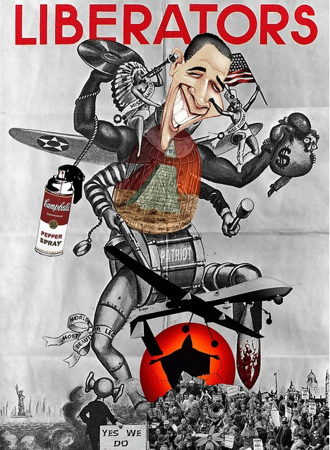Painting by William Banzai 7
For example:
- Obama is implementing the Neocon plan for regime change throughout the Middle East and North Africa
- Obama has increased the number of drone strikes, labeling all young men in conflict zones as probable bad guys. Obama has appointed himself sole “decider” as to who lives and who dies
- A top legal expert says:
President Obama … says that he can kill [any American citizen without any charge and] on his own discretion. He can jail you indefinitely on his own discretion.
- Obama has continued the state of emergency declared on 911 – and renewed every year since – and may even have continued the extra-constitutional state of government declared on 9/11 (no one has given a definitive answer one way or the other)
- Spying on Americans has ramped up much more under Obama than Bush
- Obama has continued an economic system begun under Bush which is literally more fascist than capitalist
- The government uses arbitrary, shifting definitions of enemies. For example, while Al Qaeda has been our “mortal enemy” since 9/11 … now they are our close ally. Yet the government might label anyone anywhere in the world terrorists if they do what we do… without our permission. And government agencies under the Obama administration are labeling the most mundane, normal American behavior as potential terrorism
- The federal government under Obama used such brutal violence to break up the Occupy protests (see this, this, this, this, this, this, this, this, this, this, this and this) that the Egyptian military used the crack down on Occupy as justification for the murder of protesters in Tahir Square, Egypt.
Indeed, there is overwhelming evidence that the U.S. is quickly drifting into tyranny. Seethis, this, this, this, this, this, this, this and this.
We would argue that the problem of tyranny goes beyond Obama, or the Neocons or Strauss or even Schmitt.
The problem is that 4% of the the population are psychopaths. Unless people evolve to the point where they can spot the sociopaths in our midst, we will continue to be controlled by them, and to suffer at their hands.

Why We Are Drifting Towards Fascism (And What We Can Do About It)
Ultimately, we are drifting towards fascism because the majority of people aren’t standing up for ourselves. We are letting the authoritarians have their way.
The good news is that the longest-running sociological study ever shows that only 25% of people are authoritarians. And most people are not psychopaths.
The truth is that we have overwhelming numbers (and see this). If we worked together we would win.
We need not be victims to the psychopaths who would want to control us. We can evolve and empower ourselves.
At a deeper level, if we are disconnected from out own thoughts, our own feelings and our own soul, then we will look to others to tell us what to do. We will follow the strong leader protecting us from imagined crises and made up enemies, as advocated by Schmitt and Strauss.
Only a re-connection with ourselves, our communities and our souls will act as antibodies to the insane ramblings of those who would manipulate us in order to gain total control over society and to carry out their infantile fantasy of destroying all enemies.
Schmitt, Strauss, Yoo and all of the other boneheads who have adopted a crazed disconnection from reality are worshippers of “thanatos” … the “drive towards death” diagnosed by Freud and others. Many of them write lustfully about the beauty of the noble death on the battlefield.
Sanity lies in reconnection with the beauty of the everyday: the beauty of nature, of lovers, of children, of community, of an intellectual insight, of a brilliant engineering breakthrough, of a life of service, of art, of quiet prayer and meditation.
We need to reconnect with the beauty of life … and the fact that deep down inside (despite different clothes, languages and customs) everyone’s blood is red, and everyone wants the same basic things: a little food, a little comfort, a little love, a little inspiration.
In the end, the brutal murderers and tyrants are children. Real men stand up to fascism.
Fear makes people stupid and cowardly … and willing to follow the authoritarian leader into the depths of hell. On the other hand, real courage and strength comes from love for life and passion.
Insanity may be contagious. But courage is contagious as well. And as scared as we may be of the powers-that-be, they’re even more terrified of us.
Love and courage are the antitodes [antidotes]: they are what make us fully human, and able to defeat the psychosis of Schmitt, Strauss and the perennial crazies who would crush humanity.

Average:

